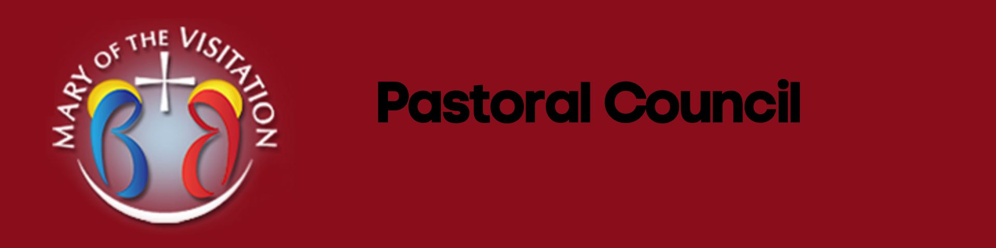
Mary of the Visitation
Pastoral Council Meeting Minutes
Tuesday, May 28th, 2024
West Campus, Becker
7:00 pm

- Opening Prayer

- Members Present
  - Father Mike, Andy Oedling, Vern Juerk, Bonnie DeZelar, Ron Dietl, Brenda Ewing, Sandi Ferris
  - Parish Council 2023-24

- Parishioner Input
  - No Parishioners Present

- Ministry Team Updates
  - Finance
    - Budget is looking good. Currently we are $20,000 over budget. Last week we covered the cost of the Raffle with the tickets that were sold. We have a few big building projects that need to be addressed. This is a good year to sell house in Big Lake used for the youth groups and storage. Could perhaps sell it for $380,000-$400,000. It is in a nice location and a big lot. 3 car garage. Sell the house to pay for the projects that are needed. There are some funds that we have saved up. Faith formation isn’t using it at this time.
  - Liturgy
    - New program was purchased to help with recordkeeping, The previous program was old and outdated and not user friendly. Now more staff are able to access the information that they need. Using that system to help find out what the needs of the church and lining up with people with who are willing to help with those needs. The portal that we are using is very user friendly. Amber is in charge of communications. Question was brought up about having the Holy days of obligation. Yes we will do that and be sure that they are on the website. The app is really good as well.
  - Building & Grounds
    - Landscaping in Becker- Can the youth group start taking out some of the old landscaping and clean it up? With the repair of the roof and door to the church we will be needing to have some items removed. Most likely need to get some trees removed. We will reach out to Nick and ask him to get started.
  - Faith Formation
    - New Faith Formation Director - Kevin Sharp. Was at Christ our Light. The position is a point position with Zimmerman-Princeton. He will oversee and be the director at both parishes. He likes what we have in K-6 and will do something different at the 7-12 level.
    - Celebration for Barb will be at the end of June. Amber and Emily are incredible at their roles!!
  - Knights of Columbus
    - Gave away 40 scholarships this year to graduating seniors. 20 in Becker 20 in Big Lake. $20,000 in scholarships. They are also handing out Tootsie rolls. There was a Feed the body and soul program held recently that was very successful. Lots of speakers that talked about prayer.
  - Pastoral Council
    - Bonnie and Brenda are done serving at the end of this year. We are looking for people to invite to ask.
  - Youth Group
    - We will ask for an update from Nick to find out if they have any needs. We would like to give an update to the parish. When they know what is needed they often give and donate
  - Building project
    - At Becker we need to repair the roof and door. Entrance needs to be fixed. Would like that to happen this summer.
- Closing Prayer

NEXT Meeting: June 25th, 2024
Becker Campus

